Licensing Authority APPENDIX THREE

Cumulative Impact Assessment 2022

- Cumulative Impact Assessments – Background

  - The concept of cumulative impact has been described within the Secretary of State’s Guidance since the commencement of the 2003 Act.
  - The guidance describes cumulative impact as “the potential impact on the promotion of the licensing objectives of a number of licensed premises concentrated in one area”.
  - For clarity, the licensing objectives are:
- Prevention of crime and disorder
- Prevention of a public nuisance
- Public safety
- Protection of children from harm
  - The Licensing Authority had previously adopted a Special Saturation Policy within its Statement of Licensing Policy, which covered both Oxford City Centre and East Oxford, adopted following assessment of the particular impact from the concentration of licensed premises in those areas. Due to the effects of the COVID-19 pandemic, the Authority was unable to conduct a Cumulative Impact Assessment when the Statement of Licensing Policy was due to be reviewed in early 2021. The result was that the Special Saturation Policy was removed, with the understanding that it would be reassessed later in the year.
  - The Policing and Crime Act 2017 amended the Licensing Act 2003 to place ‘Cumulative Impact Assessments’ on a statutory footing by introducing paragraph 5a of the Licensing Act 2003. This amendment came into force on 6th April 2018.
  - This Cumulative Impact Assessment is therefore being published under these new provisions of the Licensing Act 2003. The policy will be reviewed no later than every three years from the date it comes into force.
  - Section 182 Guidance states that “A Cumulative Impact Assessment (CIA) may be published by a licensing authority to help it to limit the number or types of licence applications granted in areas where there is evidence to show that the number or density of licensed premises in the area is having a cumulative impact and leading to problems which are undermining the licensing objectives. CIAs relate to applications for new premises licences and club premises certificates and applications to vary existing premises licences and club premises certificates in a specified area”.
- Consultation
  - As per section 5a of the Licensing Act 2003, in preparing the Cumulative Impact Assessment the Licensing Authority consulted with the persons mentioned in section 5(3) of the Licensing Act 2003, namely:
- the Chief Officer of Police
- the Chief Officer of the Fire and Rescue Service
- persons/bodies representative of the Local Authority with the function of public health
- persons/bodies representative of local holders of premises licences
- persons/bodies representative of local holders of club premises certificates
- persons/bodies representative of local holders of personal licences
- persons/bodies representative of businesses and residents in the City of Oxford
- persons/bodies representative of Child Protection Services
- other organisations as appear to the Licensing Authority to be affected by licensing matters, including local community, cultural, educational and entertainment organisations.
  - The Licensing Authority considered the views of all those consulted prior to determining this policy.

- Cumulative Impact Assessment
  - The assessment relates to all premises within specified areas that have a premises licence or a club premises certificate which will be carrying on or proposing to carry on the following licensable activities:
- The sale or supply of alcohol on or off the premises
- The provision of late night refreshment on or off the premises
  - CIAs do not apply to Temporary Event Notices (TENS); however it is open to the police and environmental health authority (as relevant persons) to refer to evidence published within a CIA when objecting to a TEN.
  - While the evidence underpinning the publication of this CIA should generally be suitable as the basis for a decision to refuse an application or impose conditions, it does not change the fundamental way that decisions are made under the 2003 Act. Each decision in an area subject to a CIA therefore still needs to be made on a case-by-case basis and with a view to what is appropriate for the promotion of the licensing objectives. Importantly, the publication of this CIA would not remove the Licensing Authority’s discretion to grant applications for new licences or applications to vary existing licences, where the Authority considers this to be appropriate in the light of the individual circumstances of the case.
  - It also does not remove the requirement for a relevant representation to be submitted by a responsible authority or a member of the public (defined as ‘any other person’ within the act) against an application for it to be considered by the Licensing Sub-Committee. An application that does not receive relevant representations is deemed granted under the Act.
  - The Licensing Authority’s Special Saturation Policy creates a rebuttable presumption that an application within the designated cumulative impact areas for new premises licences or variations that are likely to add to the existing cumulative impact will normally be refused if relevant representations are received. It is for the applicant to demonstrate that their application would not add to the cumulative impact of such licensed premises in the areas. Applicants are encouraged to liaise with the Licensing Authority and other Responsible Authorities in advance of submitting an application.
  - The steps followed in considering whether to publish a CIA are summarised below:
- Identify concern about crime and disorder; public safety; public nuisance or protection of children from harm in a particular location.
- Consider whether there is good evidence that crime and disorder or nuisance are occurring, or whether there are activities which pose a threat to public safety or the protection of children from harm.
- If there is evidence that such problems are occurring, identify whether these problems are being caused by the customers of licensed premises, or that cumulative impact is imminent.
- Identify the boundaries of the area where problems are occurring (this can involve mapping where the problems occur and identifying specific streets or localities where such problems arise).
- Consult those specified in section 5(3) of the 2003 Act. As with consultations in respect of the licensing policy statement as a whole, it is for each licensing authority to determine the extent of the consultation it should undertake in respect of a CIA (subject to the statutory requirements).
  - The Licensing Authority had previously adopted a special policy on cumulative effect, known as its Special Saturation Policy, and it is now being readopted following this Cumulative Impact Assessment.
- Cumulative Impact Assessment Statement
  - This assessment is being published because the authority is of the opinion that the number of licensed premises and club premises certificates within the City Centre and the East Oxford area is such that it is likely that granting further licences or variation to licences would be inconsistent with the authority’s duty to promote the licensing objectives. This opinion has been reached after careful consideration of evidence and data, from Thames Valley Police, the Responsible Authorities and other persons, which show high levels of public nuisance, anti-social behaviour and crime and disorder within these areas. Therefore it is appropriate and necessary to control the cumulative impact in these areas.
The areas covered by the policy are the City Centre, as shown in Appendix One, and East Oxford, predominately Cowley Road, as shown in Appendix Two.
The evidential basis for the decision to publish a Cumulative Impact Assessment is set out in Appendix Three.
In areas where there is an excessive accumulation of off and on licensed premises, it is relatively straight forward to provide a direct correlation between those premises and public nuisance, anti-social behaviour and crime and disorder in the area, through an analysis of the evidence including operating hours of the premises and the peak times for incidents and calls for service.
- Other mechanisms for controlling cumulative impact
  - There are mechanisms and interventions, both within and outside the licensing regime, that are available for mitigating adverse impacts on the licensing objectives and should be considered alongside local licensing policy by the Licensing Authority, Responsible Authorities, other persons, licensed premises and new and existing applicants: For example:
- planning controls
- positive measures to create a safe and clean environment in partnership with local businesses, transport operators and others
- the provision of CCTV,
- ample taxi ranks and Private Hire Companies licensed within district
- powers to designate parts of the city as places where alcohol may not be consumed publicly-Public Space Protection Orders.
- confiscation of alcohol from adults and children in designated areas
- police enforcement of the law with regard to disorder and anti-social behaviour, including the issuing of fixed penalty notices
- enforcement action against those selling alcohol to people who are inebriated
- police powers to close some premises for up to 24 hours on the grounds of disorder, the likelihood of disorder or excessive noise
- the power of police, local businesses or residents to seek a review of the licence or certificate

Appendix One – Cumulative Impact Area – Oxford City Centre
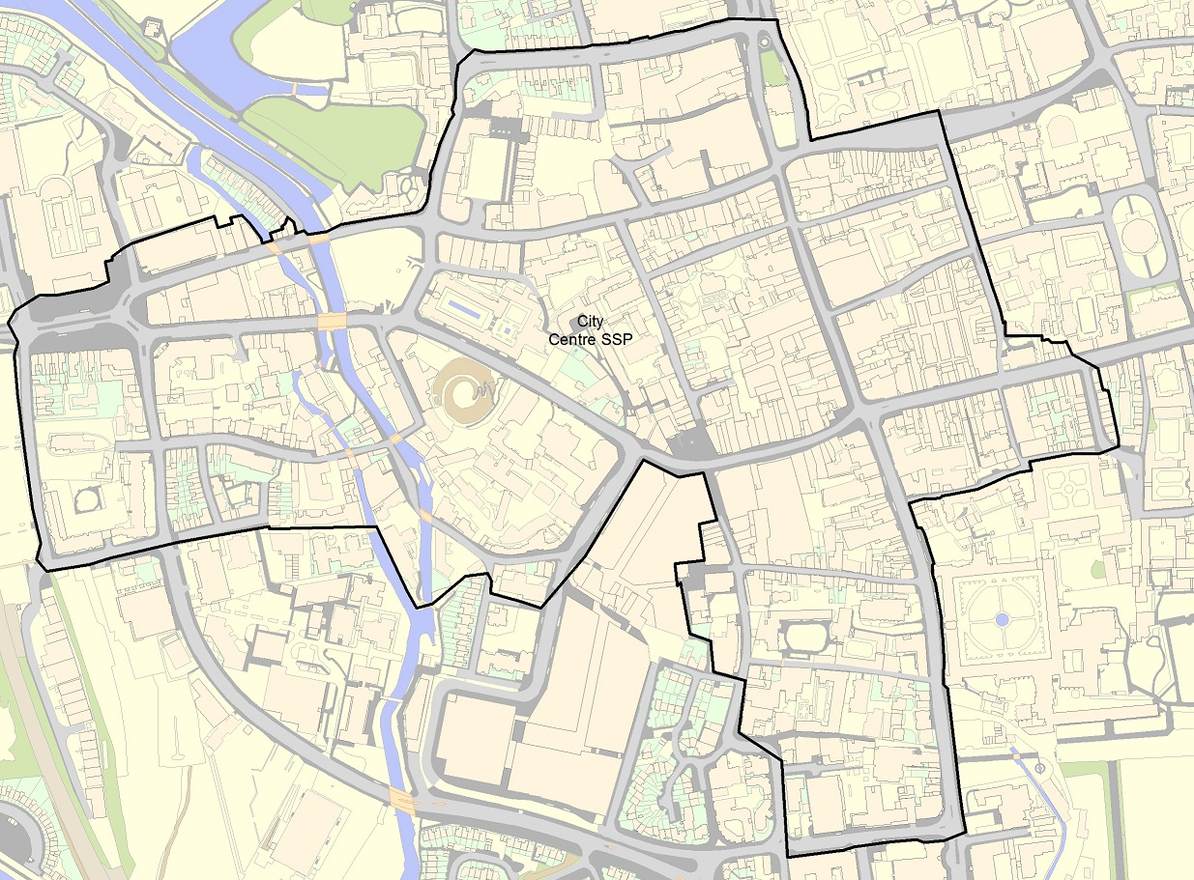

Appendix Two – Cumulative Impact Area – East Oxford
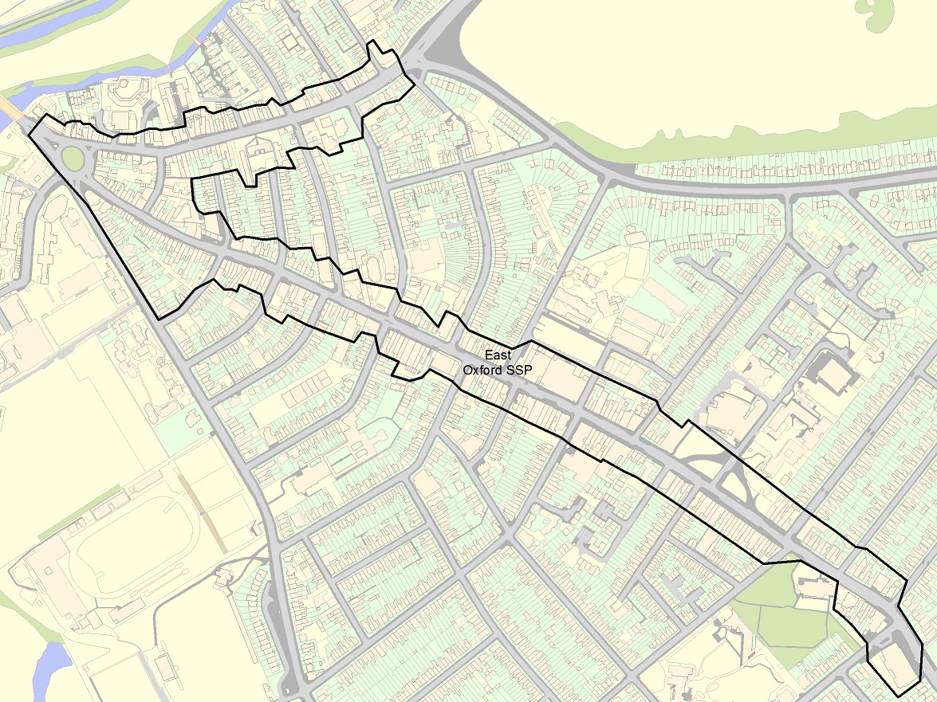

Appendix Three – Cumulative Impact Evidence
Contents
- Police ASB incidents 2020 – LSOA level
- Police Criminal damage crimes 2020 – LSOA level
- Police Public Order crimes 2020 – LSOA level
- Police Violent crime and sexual offences 2020 – LSOA level
- Seasonal trends of top-4 LSOAs
- CCTV incidents
- Police data analysis methodology
- Temporal analysis
- Seasonal analysis
- Geographic distribution: all NTE occurrences
- Geographical distribution: serious violence occurrences
- Public Health data – alcohol related admissions and mortality rates
Glossary
LSOA – Lower Super Output Area
ASB – Anti-social Behaviour

- Police ASB incidents 2020 – LSOA level
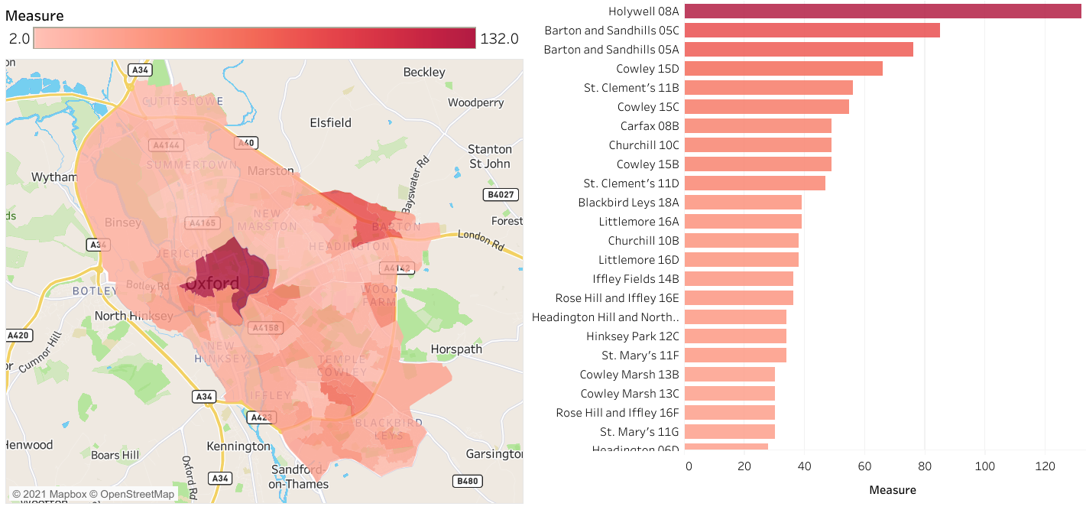

- Police criminal damage and arson crimes 2020 – LSOA level
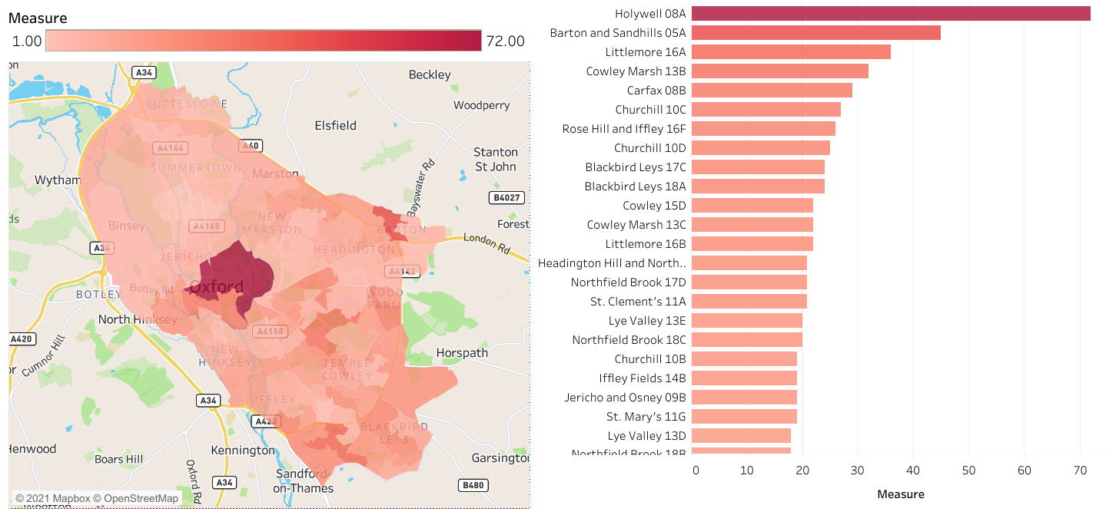
- Police Public Order crimes 2020 – LSOA level
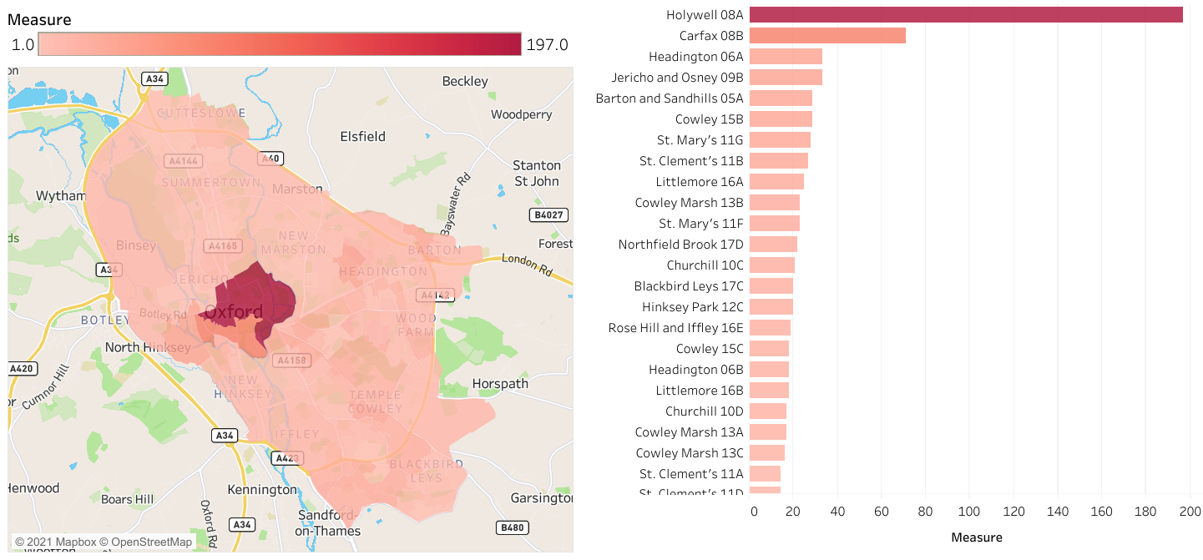

- Police Violent crime and sexual offences 2020 – LSOA level
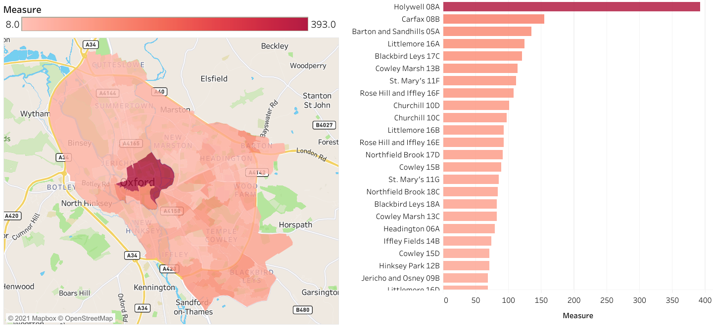
- Police crime trend data – top 4 LSOAs
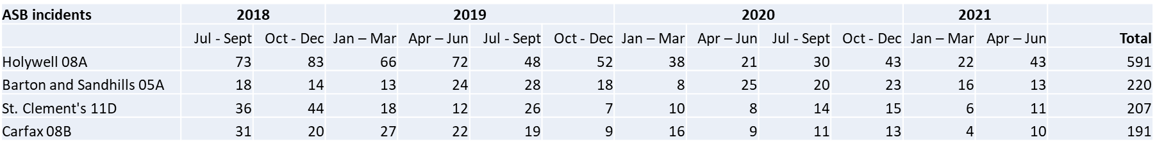
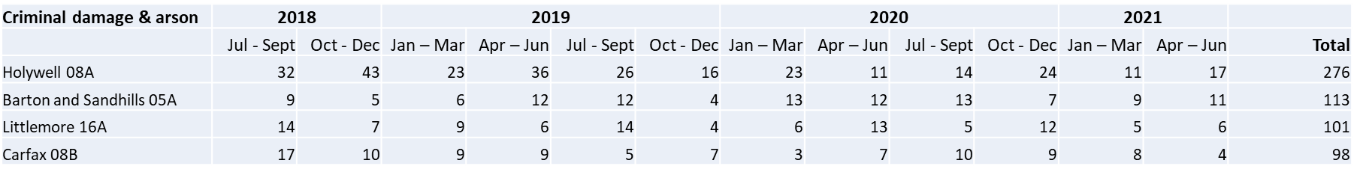
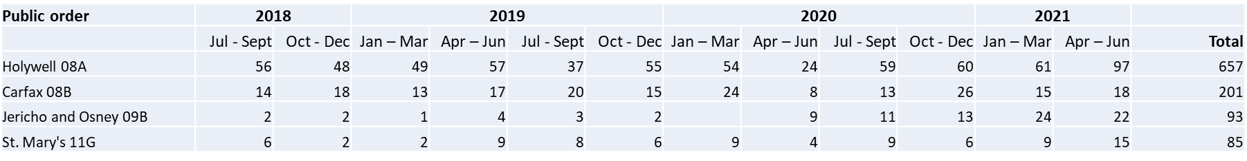
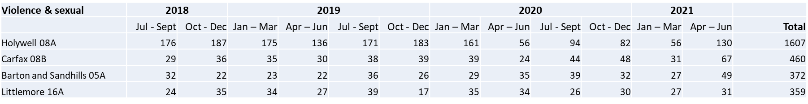

- CCTV incidents

The graph illustrates the peak hours of incidents monitored by public space CCTV cameras in the city. It is not possible to disaggregate the small number of cameras in neighbourhood areas from the cameras in the city centre.
This hourly breakdown is clearly linked to public space incidents during the night-time economy period.
- Police Analysis of Violent Crime in the NTE: Methodology
Data from the police occurrence record keeping system for occurrences taking place within the Oxford Local Police Area with a reported date between 01/01/2017 and 26/04/2021 and with the Home Office Statistics Code 1 representing Violence Against the Person or Disorder.
Cancelled, historic or occurrences where the date was unknown were removed from the data set.
VAP and Disorder are very broad categories and include many occurrences unrelated to the NTE, attempts were made to refine the focus of the data by removing occurrences where the Location was recorded as a Dwelling or using the following criteria:
The data set resulting from the described initial search and filtering criteria comprised 4,523 occurrences which were considered to be related to Oxford’s Night Time Economy. This data set was then analysed using Microsoft Excel and Esri ArcMap.

- Police Analysis of Violent Crime in the NTE: Temporal Distribution
The temporal distribution of the 4,514 occurrences for which a time could be determined is shown below. It should be noted that 314 of these had an Event Start Time recorded as 00:00 – upon further investigation 305 of these were changed to a more accurate time based on Recorded Time, Event End Time and times noted in the summary report.
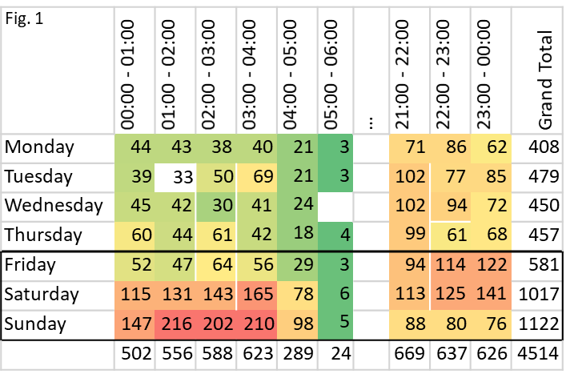

Figure 1: Distribution of occurrences by time and day of week
Shows what we might expect intuitively: almost half (47%) of occurrences linked to Oxford’s NTE occur on either a Saturday or a Sunday. The busiest period is between 01:00 and 04:00 on a Sunday morning, with those 3 hours alone accounting for 14% of occurrences analysed.
Fig. 2 | 00:00 ‐ 01:00 | 01:00 ‐ 02:00 | 02:00 ‐ 03:00 | 03:00 ‐ 04:00 | 04:00 ‐ 05:00 | 05:00 ‐ 06:00 | … | 21:00 ‐ 22:00 | 22:00 ‐ 23:00 | 23:00 ‐ 00:00 | Grand Total
Monday | 12 | 9 | 7 | 5 | 5 | 1 |  | 3 | 4 | 3 | 49
Tuesday | 11 | 6 | 12 | 18 | 16 | 8 |  | 2 | 5 | 7 | 85
Wednesday | 7 | 8 | 5 | 5 | 3 | 3 |  | 2 | 2 | 7 | 42
Thursday | 13 | 10 | 13 | 9 | 15 | 3 |  | 6 | 2 | 5 | 76
Friday | 6 | 12 | 7 | 8 | 10 | 2 |  | 11 | 7 | 5 | 68
Saturday | 15 | 27 | 32 | 28 | 40 | 16 |  | 10 | 5 | 14 | 187
Sunday | 18 | 59 | 52 | 41 | 59 | 22 |  | 6 | 3 | 7 | 267
 | 82 | 131 | 128 | 114 | 148 | 55 |  | 40 | 28 | 48 | 774

Figure 2: Distribution of NTE‐related hospitalisations to John Radcliffe A&E by time and day of week
Shows the distribution of admissions to the Accident & Emergency department of the John Radcliffe hospital between August 2017 and August 2020 which were classified as Apparent Assaults in which alcohol was believed to be a factor. The distribution largely mirrors the conclusion drawn from analysis of the temporal distribution of NTE‐linked occurrences in Oxford, with an even greater focus on the early hours of Sunday morning (and to a lesser extent of Saturday morning).
- Police Analysis of Violent Crime in the NTE: Seasonality

The count of NTE‐linked occurrences taking place in each month of 2017, 2018, and 2019 is illustrated below. The chart does not suggest any great degree of predictable seasonality, although it appears that occurrence counts in November and December may be particularly high. These monthly counts were then compared to the expected level (based on the 12 month centred moving average) to determine whether any months appeared to have occurrence counts consistently above the expected count.

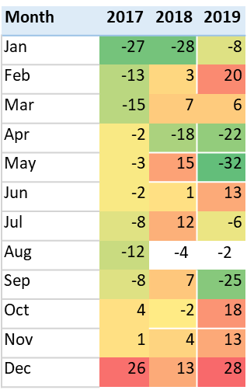
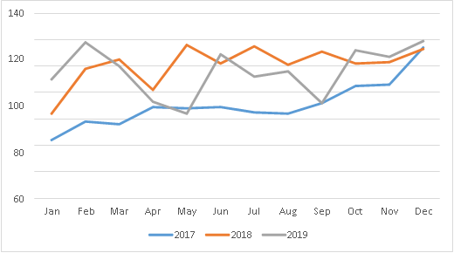

This analysis accounts for changing trends (2017 saw a steadily rising number of monthly occurrence counts, leading to consistently higher levels in 2018). It clearly shows that December NTE‐linked occurrence counts were higher than expected in every year from 2017 to 2019, and that January occurrence counts were lower than expected in every year. April and August were also consistently lower than expected, albeit to a lesser extent than January, and November was also associated with marginally higher than expected NTE occurrence counts.

- Police Analysis of Violent Crime in the NTE: Geographic distribution

The following heat maps show locations of NTE occurrences in Oxford, using a 100m x 100m grid overlaid on a map of the police area with the count of occurrences recorded as taking place within each grid square being indicated by the colour of the square.
The map clearly indicates that the most notable areas in which NTE occurrences have taken place are: the city centre area focused on Park End Street, Hythe Bridge Street and Cornmarket; Magdalen roundabout, the Cowley Road between Union Street and East Avenue (O2 Academy and Cowley Retreat area); the A&E department of the John Radcliffe Hospital; and the Littlemore Mental Health Centre. It is possible (although not confirmed) that the hospital events may include occurrences that took place elsewhere and were reported from the hospital location.

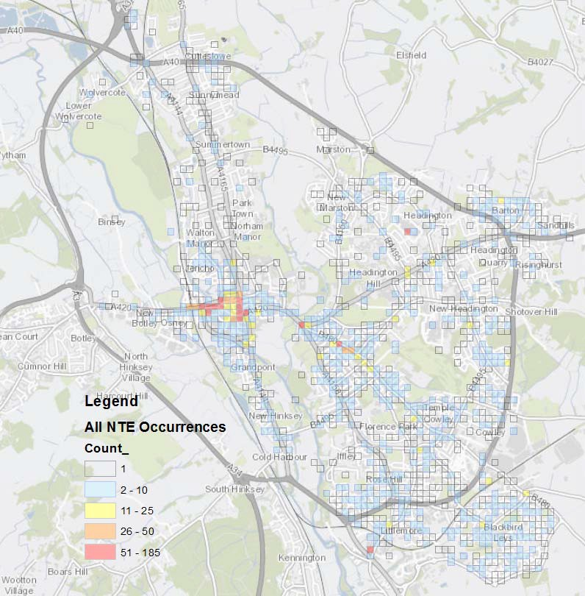

- Police Analysis of Violent Crime in the NTE: Geographic distribution

Serious violence offences.
Serious violence in Oxford’s NTE appears to be highly focused in city centre areas, in particular: Queen Street / Cornmarket Street and Park End Street / Hythe Bridge Street.

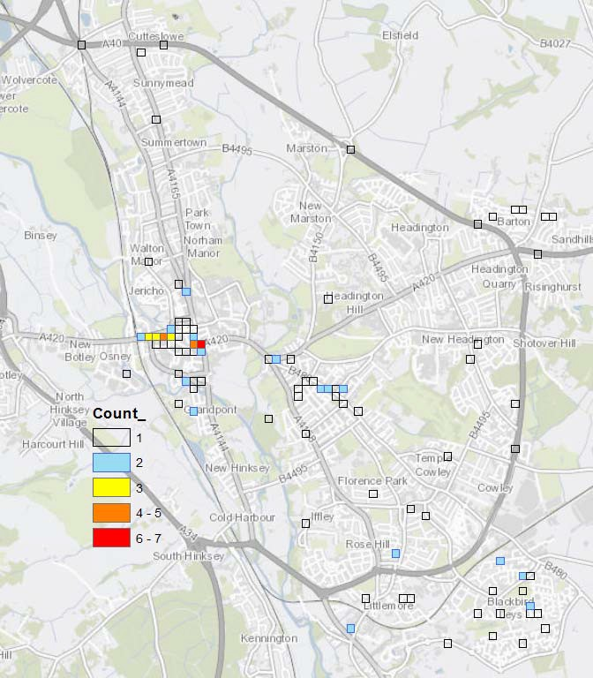

- Public Health Data

The table below shows the alcohol related hospital admissions and mortality rates for Oxford.

Compared to England: better similar worse
Indicator | Period | England | Oxfordshire | Oxford
Alcohol related mortality | 2018 | 46.5 | 41.1 | 48.6
Admission episodes for alcohol related conditions | 2018-19 | 664 | 526 | 640
Admission episodes for alcohol specific conditions | 2018-9 | 626 | 522 | 741
Admission episodes for alcohol specific conditions -Under 18s | 2016/17-18/19 | 31.6 | 31.7 | 50.0
Hospital admissions of alcohol related cardiovascular disease (female) | 2018/19 | 776 | 613 | 791
Hospital admissions for mental and behavioural disorders due to alcohol | 2018/19 | 75.6 | 52.2 | 97.9
Hospital admissions for alcoholic liver disease | 2018/19 | 131.2 | 96.0 | 138.4
Source: PHE: Population Health Analysis (PHA) team using data from NHS Digital and ONS

The trend for hospital admissions for alcohol related conditions is increasing. There is also an increase in the trend for hospital admissions for alcohol related cardiovascular diseases.

